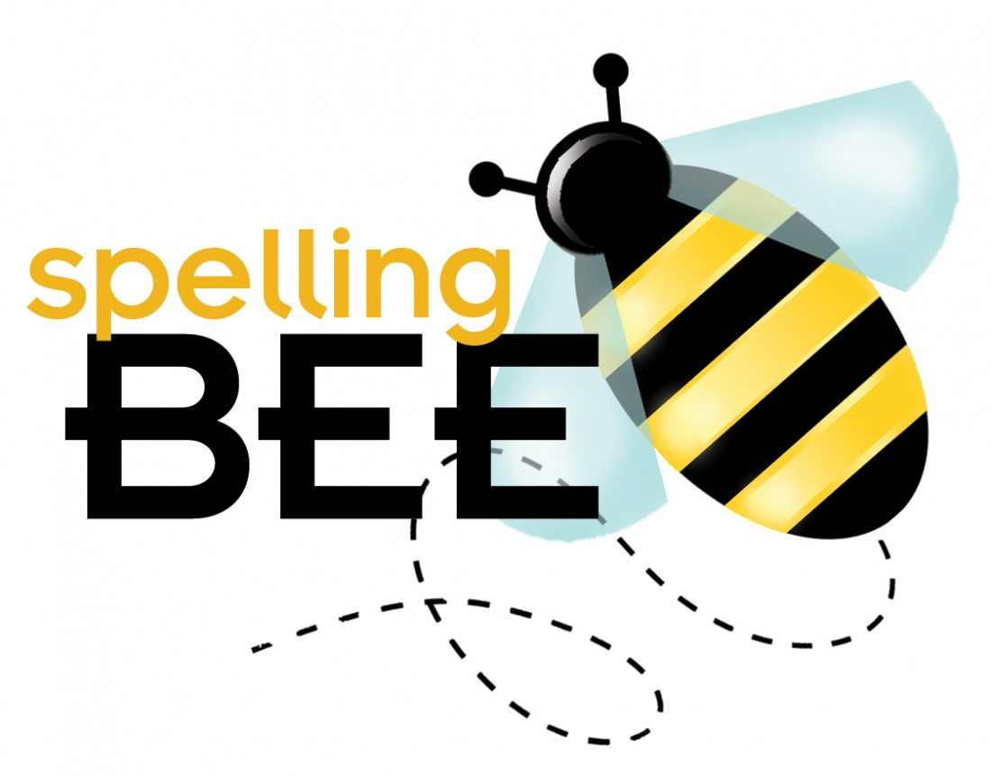
HIS Spelling Bee Competition

Monday, February 12, 2018

The Annual HIS Spelling Bee season is upon us! A spelling bee is a competition in which contestants are asked to spell a broad selection of words, usually with a varying degree of difficulty. This competition is completely optional and is currently open to all students in Grades 2 – 8.

There will be three levels of competition: Bronze Dragons (Grade 2 & 3), Silver Dragons (Grade 4 & 5) and Gold Dragons (Grade 6, 7 & 8) There will be two rounds of competition. Round 1 is a written test and Round 2 is a verbal test. Dates and times for both of these rounds of competition will be announced when we return from the Chinese New Year holiday. The winners for each section during Round 1 will move on to compete in Round 2. Students will be tested on any words up to their level and above if required, and as such are encouraged to study all provided words. Definitions have also been provided to support memorization of words. Students may ask for these definitions during the verbal spelling challenge. Students may also ask for the word to be used in a sentence. However, these sentences will not be provided for study beforehand. The word lists and definitions have been included with this post.

Two Rounds of Competition:

Round 1 will take place in the cafeteria with all interested participants being given a range of words to spell on paper. The six highest scoring entrants from each competition level will progress to the second round.

During Round 2, students will be given a range of words to spell verbally up to their level (and above if required to separate the winner. In the case of middle school, an unseen list of challenge words will be used if needed to separate the winner). Students may ask for the word definition and/or word to be used in a sentence. Students may also ask to hear the word a second time. The winner from the Bronze Dragons and Silver Dragons levels will be allowed to enter the next level’s competition. All finalists will receive a certificate award and t-shirt, and the winner of each level will receive a special award.

The HIS Spelling Bee is designed to support our phonics and grammar programs, and intended to be a fun and motivational activity. All decisions made by the organizers of the competition are final. While we will always ask for feedback about our activities and programs, we appreciate in advance your understanding that this competition is organized in good faith.

We hope this information helps, and happy spelling!

Ms. Tanya & Ms. Maxwell

